Quarter 1 Prism

Jonathan Rodriguez

# Summary

Throughout the quarter, I personally contributed to the game’s development by designing it through various tools and techniques, such as planning documentation on Google Docs, creating drawings on FigJam, generating tasks in Jira, and making progress on Unity while pushing it to Github.

# Design

## **Mockup**

Our team engaged in extensive discussions regarding the game’s concept, during which I helped facilitate the fusion of different ideas and made sense of the game’s damage and color mechanics.

## **User Stories**

Our group created user stories on Figma and Google Docs in which we described events the user experienced such as items, enemies, damage, bosses, and map.

### *Descriptions*

In Figma I created the AI boss descriptions and scripts they would run by getting information from the player.

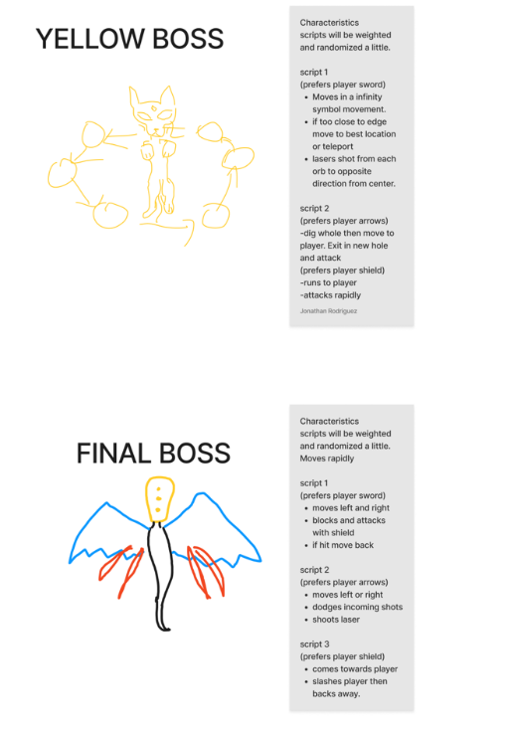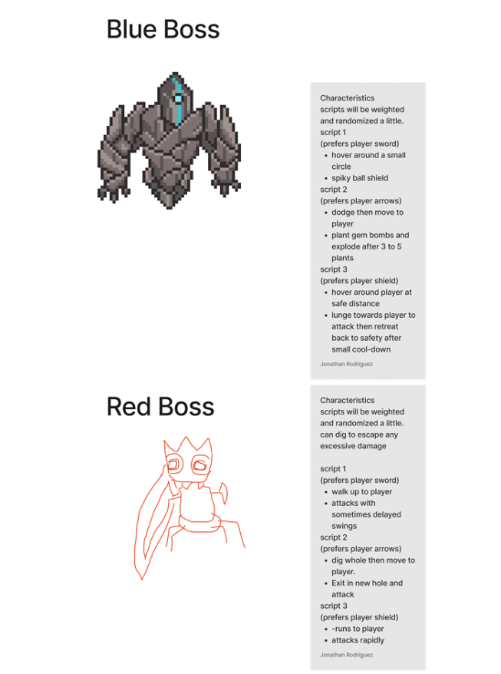I created the AI boss scenarios and devised various user experience scenarios involving their interactions with the bosses.

### *Scenarios*

Blue, red, yellow, and final boss will have scenarios that base off what scripts with attacks and movements.

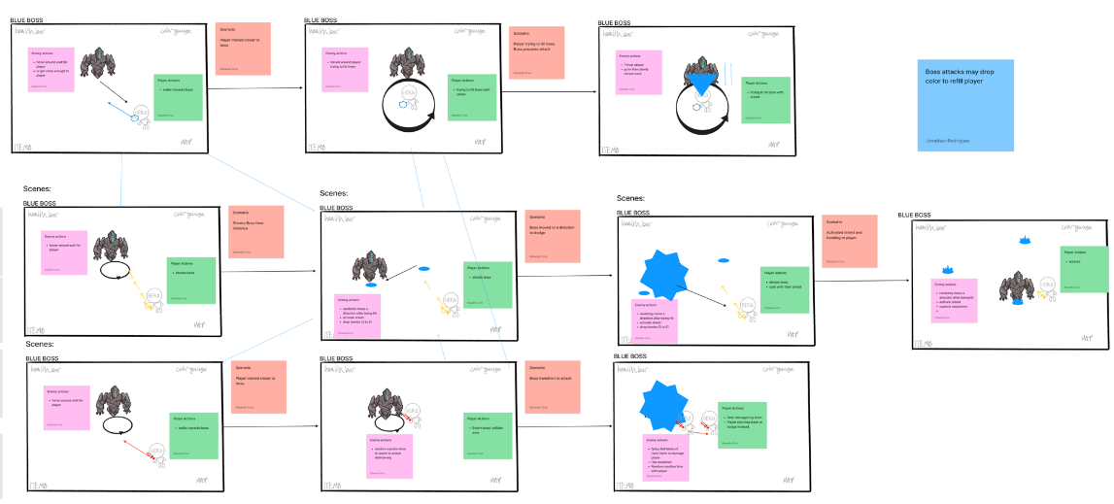BLUE BOSS

* Closed Ranged
* Shield Attacks
* Fights close to player

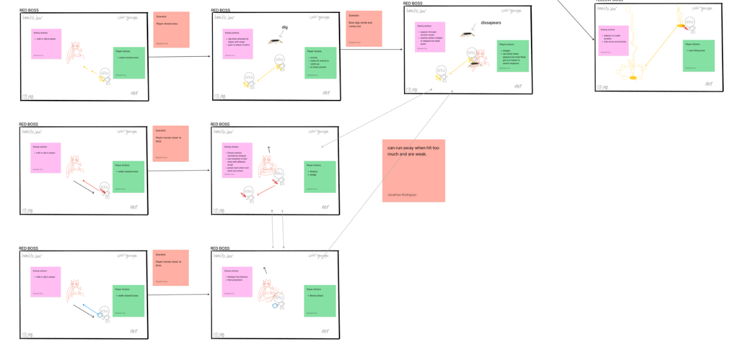RED BOSS

* Close Ranged
* Melee Attacks

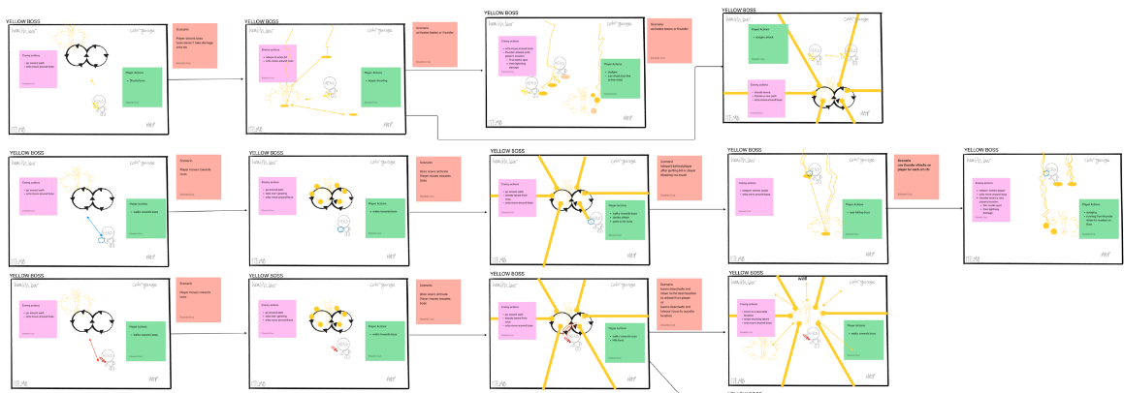

YELLOW BOSS

* Far Ranged
* Range Attacks

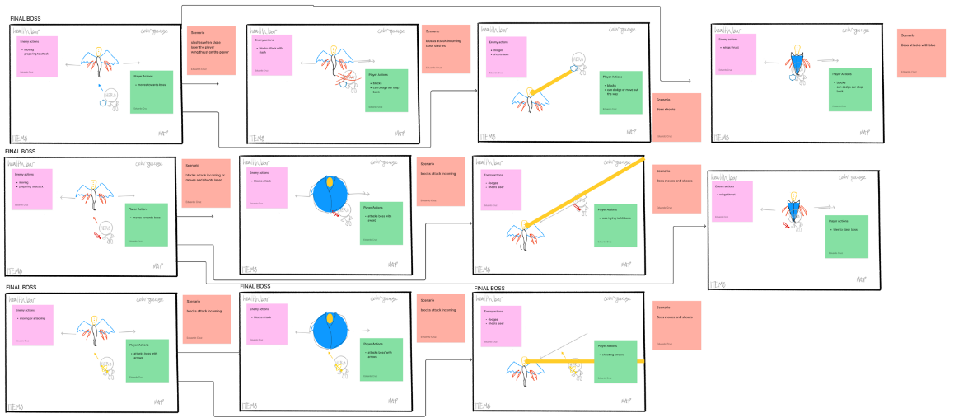

FINAL BOSS

* Far/Closed Ranged
* Shield, Melee, Range Attacks

# Task

Jira was utilized by the team to create tasks and sprints for scenarios, enabling us to complete the foundational elements of the game in a week. This strategic approach was designed to avoid any potential delays in future tasks that may rely on preceding ones.

I worked with my teammates to create a sprint in Jira, and helped decide who would do each task. I focused on picking up items and displaying the weapon icons and color bars in the user interface. I also guided my teammates in how to approach their tasks since they’re relatively new to game development.

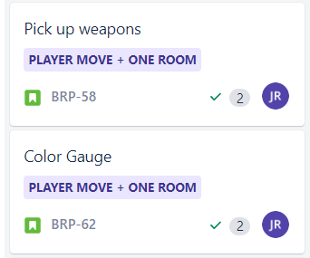 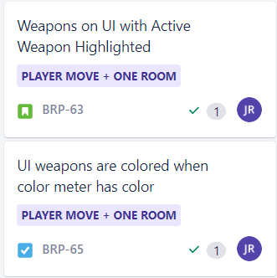

# Code

The files that I worked on primarily encompass ColorStats.cs, which facilitates the display of weapon icons and color bars on the screen, and Pickup.cs, which enables the pickup of items that affects the display of weapon icons and color bars in the user interface.

I followed a character tutorial on Youtube and added picking up weapons in the game, which are represented by icons on the screen. When a player picks up an item, it changes the uncolored weapon to colored indicating it’s been collected by changing the image on the object.

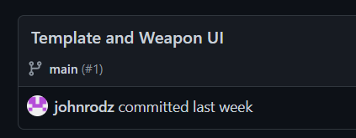

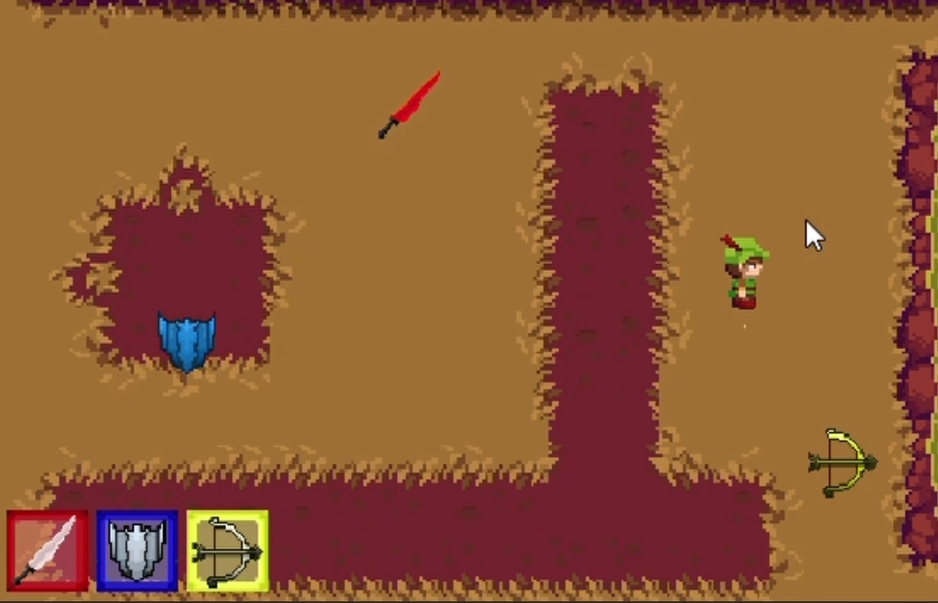 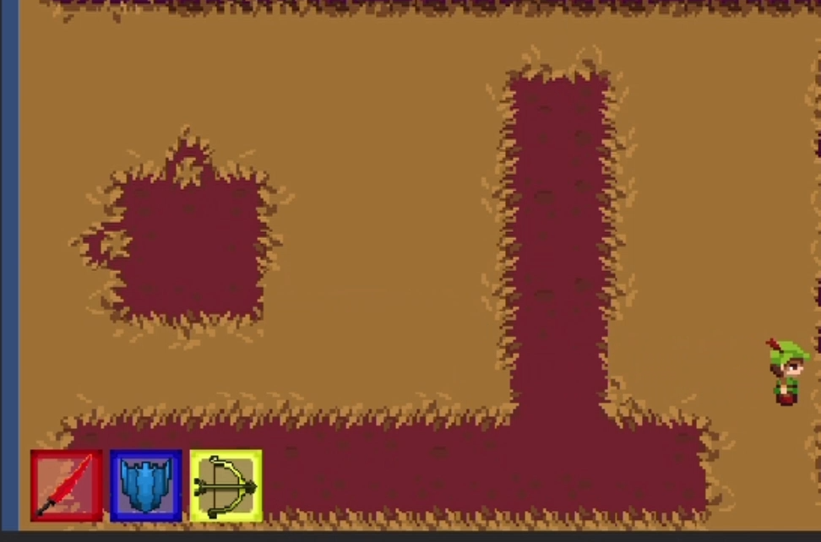

Added color bars that display how much of each color the user had for each weapon. Items dictate the amount of point given and enables and disables children inner bars from the object’s bar.

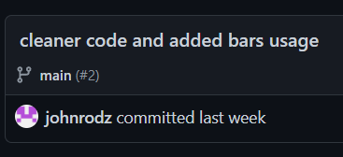

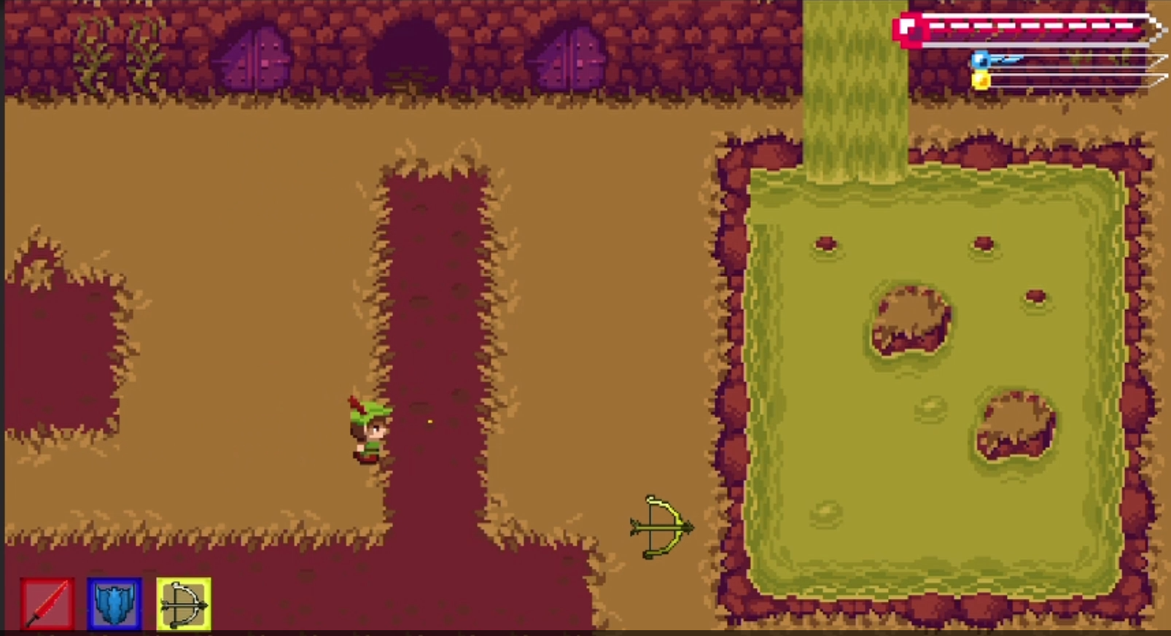

Swapped information displayed by the color bars and swaps the images of each bar, so that it appears as though the bars are changing forward or backward when player presses ‘Q’ or ‘E’ key. This is done by giving a current active state 0,1, or 2 for red, blue, or yellow.

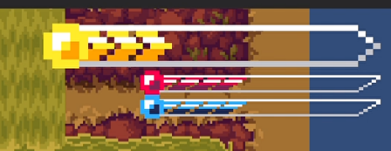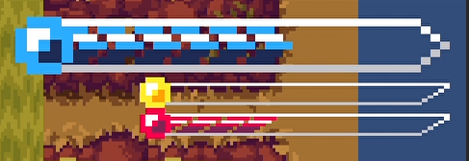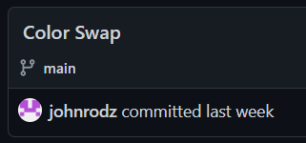

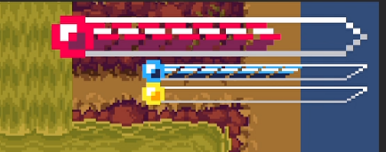

The weapon user interface now highlights the active icon corresponding to the currently selected color bar. Since we already have a working active state per color, I just swapped the image to a highlighted one per state.

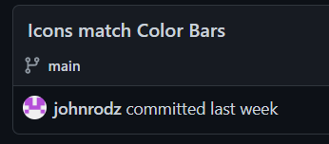

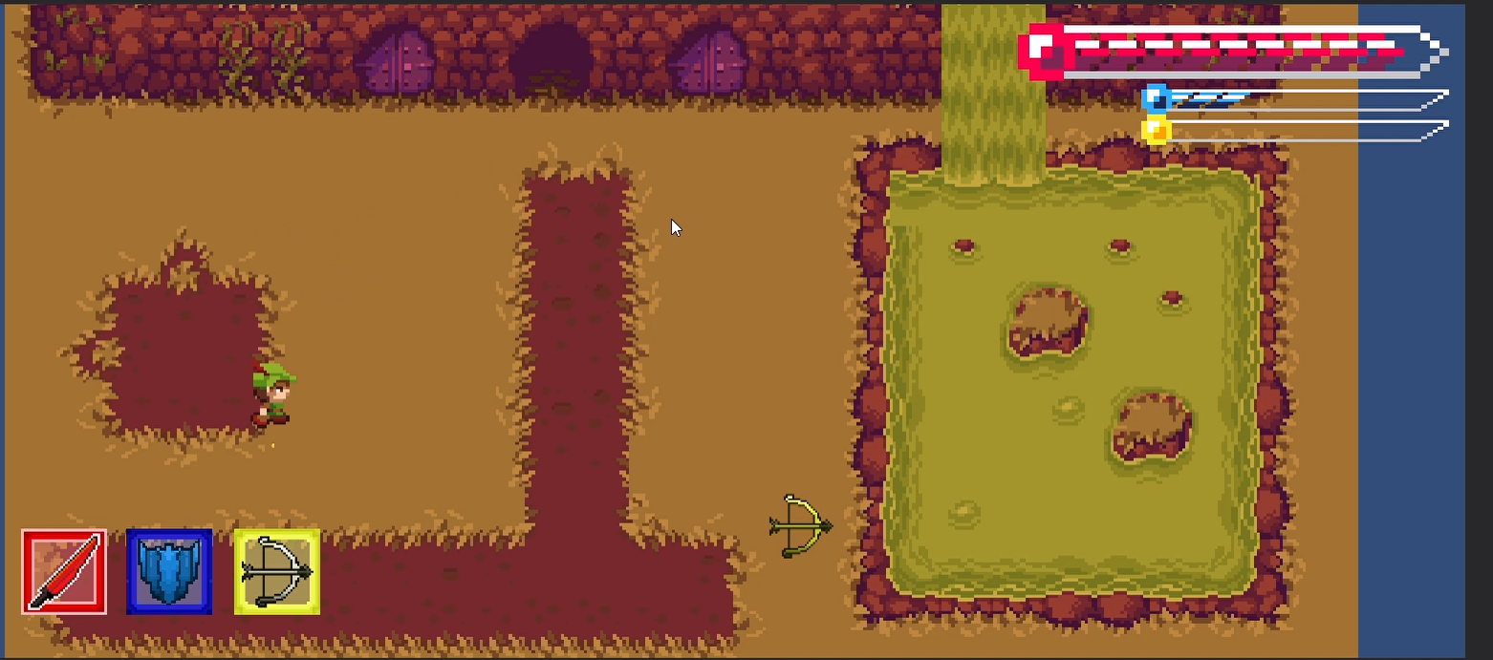

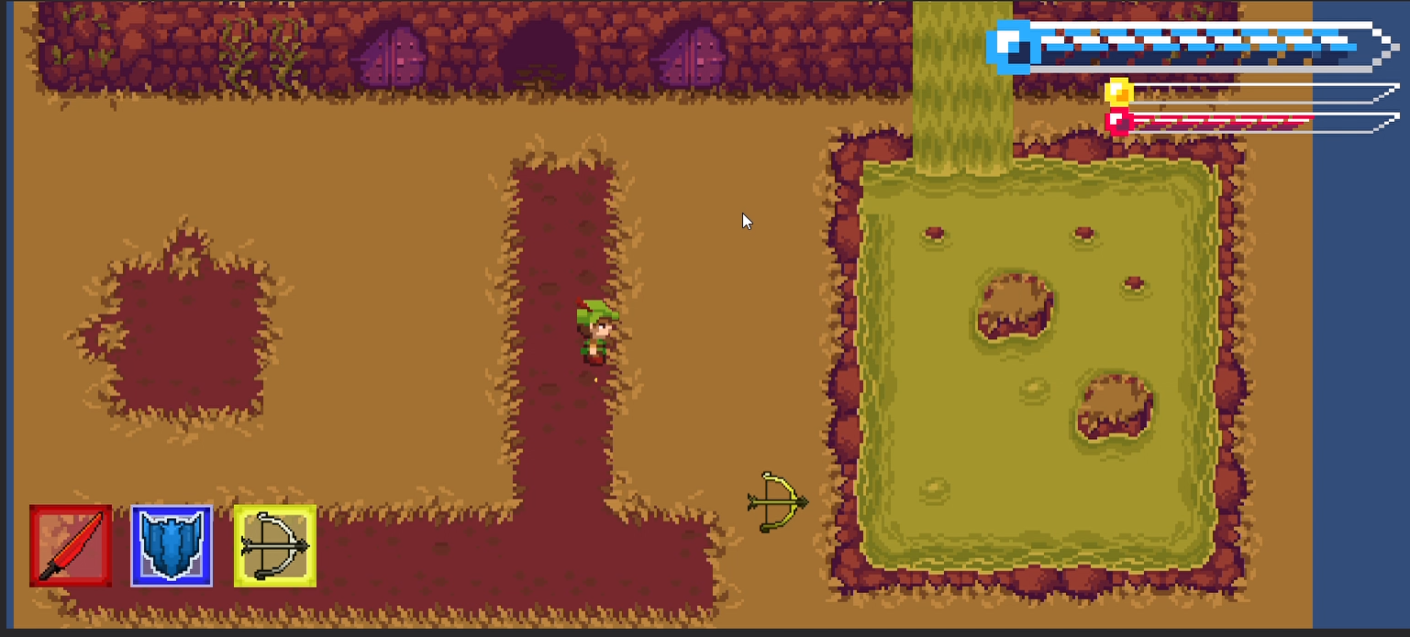

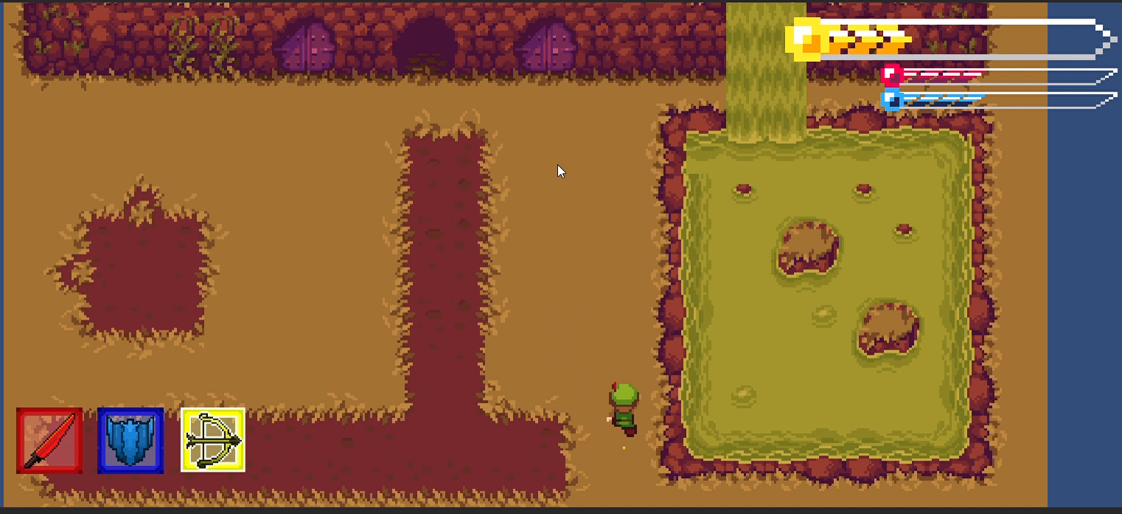

If the color bar is empty, typically because it an active color being used up, the corresponding icon changes from colored to empty. When the color bar reaches 0 it should swap the image back to a blank weapon.

